

MATHEMATICS
Methods Units 1 & 2

Test 3 – Functions, Transformations and Relations

Chapters 8 and 9
Semester 1 2019

Section Two - Calculator Assumed

Time allowed for this section
Working time for this section: 30 minutes
Marks available: 35 marks

Material required/recommended for this section

To be provided by the supervisor
This Question/Answer booklet
Formula sheet

To be provided by the candidate
Standard items: pens, pencils, pencil sharpener, eraser, correction fluid, ruler, highlighters

Special items: drawing instruments, templates, notes on one unfolded sheet of A4 paper, and up to three calculators satisfying the conditions set by the Curriculum Council for this course.

Important note to candidates
No other items may be used in this section of the examination. It is your responsibility to ensure that you do not have any unauthorised notes or other items of a non-personal nature in the examination room. If you have any unauthorised material with you, hand it to the supervisor before reading any further.

- (9 marks)
Consider the function $f\left(x\right)=x^{3}-3x^{2}-x+3$ for $-2≤x≤2.$
- On the axes provided below, sketch the graph of $f(x)$ within the specified domain. [3]

- State the range for $f(x)$ for the domain specified. Give your answers correct to one decimal place. [2]

- State the coordinates of the horizontal intercept(s) of $f(x)$ for the domain specified. [2]

- State the coordinates of the turning point(s) of $f(x)$ for the domain specified. State the nature of this point. Give your answer correct to one decimal place. [2]

- (8 marks)
Describe a series of transformations required to convert $f(x)$ into $g(x)$.
- $f\left(x\right)=x^{2}$ and $g\left(x\right)={\left(x-2\right)}^{2}+4$ [2]

- $f\left(x\right)=x^{3}$ and $g\left(x\right)=-{\left(2x\right)}^{3}$ [2]

- $f\left(x\right)=\frac{1}{x}$ and $g\left(x\right)=\frac{1}{1-x}$ [2]

- $f\left(x\right)={\left(2x+1\right)}^{2}$ and $g\left(x\right)=x^{2}$ [2]

- (9 marks)
Consider the three graphs shown below.
- State whether each is a relation or a function. [3]
- Show justification with an appropriate test. [3]
- Describe the graph using one of the terms one-to-one, one-to-many, many-to-one. [3]

Graph A Graph B Graph C
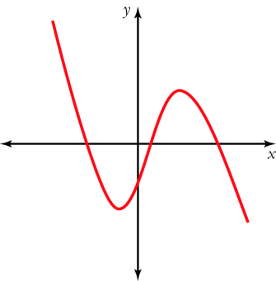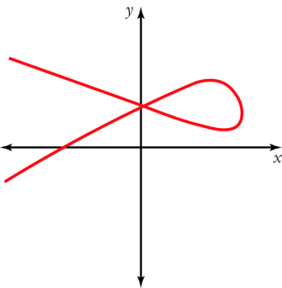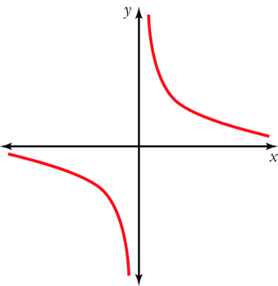

- (9 marks)
Given that $f\left(x\right)=3x-1$, $g\left(x\right)=x^{2}-2x+1$ and $h\left(x\right)=\left\{\begin{aligned}\begin{matrix}x^{2} & for & x>2\end{matrix} \\ \begin{matrix}4x & for & x≤2\end{matrix}\end{aligned}\right.$
- $f(2)$ [1]

- $g(-2)$ [1]

- $h(2)$ [1]

- $g(f\left(x\right))$ [2]

- $h(f\left(x\right))$ [2]

- $g(h\left(4\right))$ [2]

End of Test

